To meet our duties within CDM Regulations 2015 requirements, we have the following requirements in place and undertake the following to ensure compliance.

**MWS Operating Procedure - Designer**

The MWS procedure for Undertaking the role of Designer, written by our Technical Director and interprets how MWS must ensure compliance with the requirements of the Construction, Design and Management Regulations 2015.

1. 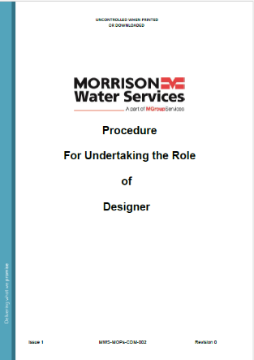**Designer Competence**
2. **Designers Role**
3. **Application of the Designers Role**
4. **Notification to Client of their Duties**
5. **Requesting Information from the Client**
6. **Identification of Lead Designer**
7. **Hazard and Risk Management**
8. **General Principles of Prevention**
9. **Provision of information by Designers**
10. **Cooperation**
11. **Design Reviews**
12. **Design Forums**
13. **Human Factors in Design**
14. **Records**
15. **Design Check**

**Design Management Plan (DMP)**

Our DMP provides the process for designers to follow and includes the CDM 2015 regulations and information from our MOPs for Undertaking the Role of Designer Procedure. The DMP sits within the hierarchy of our Business Management System.

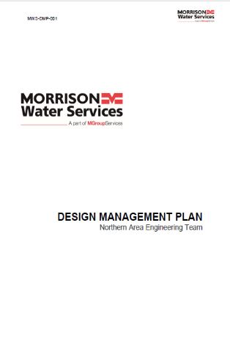

The DMP sets out the structure a design team. The role of the Principal Designer, Design Manager, Lead Designers and Designers (internal/consultants and suppliers)

The role of the MWS project team includes the Lead Designer as part of the triangle of Commercial, Operations and Design. Through these daily and weekly meetings occur to update

The **project team** will work together through the different stages of a project and be responsible for the day-to-day design activities required to ensure compliance with the relevant standards, regulations, and legislation applicable to the project. They are responsible for taking projects through design gateways as defined below.

The initial handover meeting from the Client is to review scheme details (pre-construction information) and is the first meeting to review client duties and requirements.

Most of MWS's work is PC and PD. If there are any gaps in PCI information, e.g., a survey required to support eliminating foreseeable health and safety risks, we carry these out. To fully understand the steps to reduce control risks, we conduct design risk surveys to verify.

Gaps in information/survey results are provided to the Principal Designer, if the client, or to the Principal Contractor, where MWS is PD. For example, asbestos surveys, condition surveys, and asset locations are provided to the PD. This is the initial stage of providing design information to the PD in preparation for the H&S file.

As part of the Communication, Cooperation, and Coordination throughout the design/planning stage, we ensure that all designers (including the PD) have full awareness of the Health and Safety risks/issues during the project and beyond. i.e., undertaking design activities, including surveys and design solutions.

Designer Duties Principals of Prevention

**Principal Designer Duties**

To Plan, Manage and Monitor the pre-construction stage and to coordinate H&S issues, we have three stages with the designers these are –

* Understand their duties and other duty-holders.
* Understand their responsibilities.
* Meetings & Audits through the life cycle of the pre-construction stage

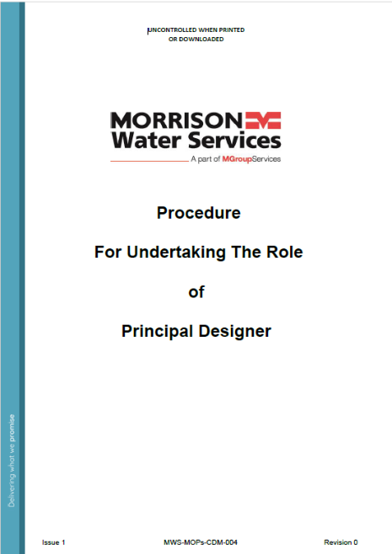

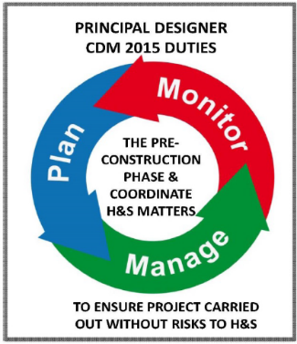

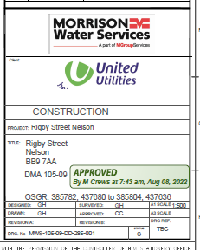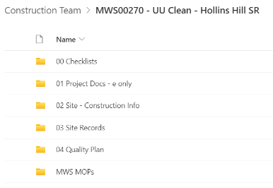Once a project has a completed design, as part of the handover meeting from Design to Construction, we ensure that the handover is communicated from the Designer to the Operations team. Included within this meeting is to provide design information for the preparation and completion of a Construction Phase Plan (CPP)

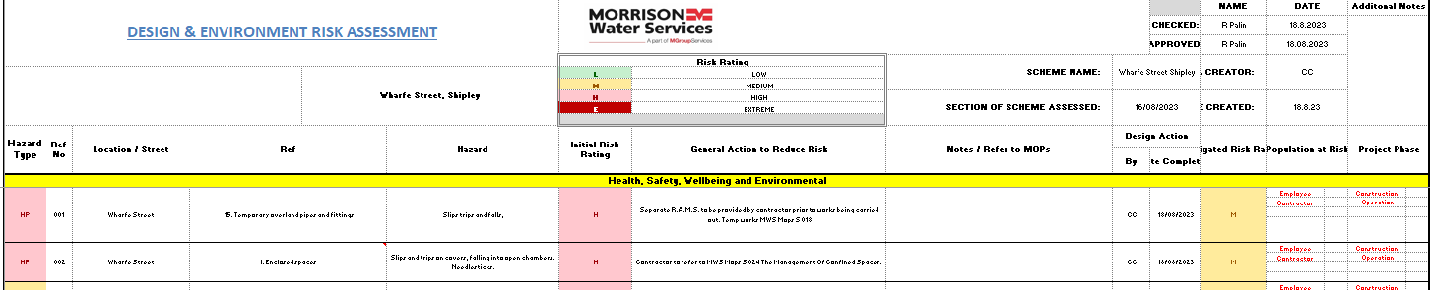We have a Design Acceptance with the client, which will provide information about the design solution, the elimination of foreseeable H&S risks, and the steps to reduce or control risk by completing the Design Risk Assessment and producing drawings showing Hazards and mitigation measures required. An example is DERA (Design and Environment Risk Assessment) and the controls required to reduce risk.

**Principal Contractor**

The Principal Contractor must:

* 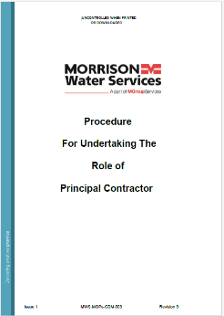Plan, manage, monitor and coordinate the entire construction phase.
* Take account of the health and safety risks to everyone affected by the work (including members of the public), in planning and managing the measures needed to control them.
* Liaise with the Client and [Principal Designer](https://www.hse.gov.uk/construction/cdm/2015/principal-designers.htm) for the duration of the project to ensure that all risks are effectively managed.
* Prepare a written [construction phase plan (PDF)](https://www.hse.gov.uk/pubns/cis80.pdf)before the construction phase begins, implement it, and then regularly review and revise it to make sure it remains fit for purpose.
* Have ongoing arrangements for managing health and safety throughout the construction phase.
* Consult and engage with workers about their health, safety and welfare.
* Ensure suitable welfare facilities are provided and maintained throughout the construction phase.
* Check who we appoint have the skills, knowledge, experience and, where relevant, the organisational capability to carry out their work safely and without risk to health.
* Ensure all [workers](https://www.hse.gov.uk/construction/cdm/2015/workers.htm) have site-specific inductions and any further information and training they need.
* Take steps to prevent unauthorised access to the site.
* Liaise with the Principal Designer to share any information relevant to the Planning, Management, Monitoring and Coordination of the pre-construction phase.